**Homework | Cycle 30 | Session 11**

* Using parameters load data from sql dn to adlsgen2
* Using parameters load data from sql dn to adlsgen2

Login into portal.azure.com and go to your resource group

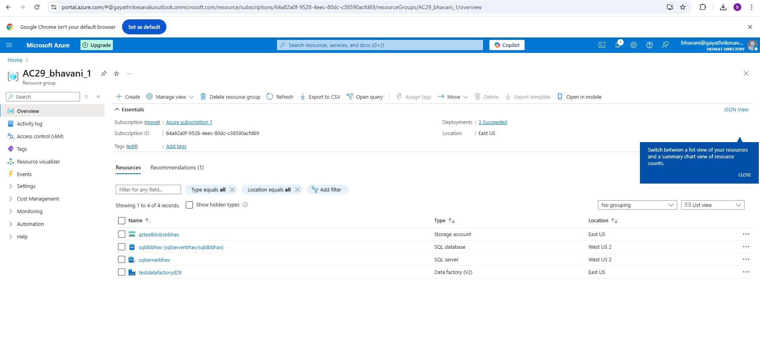Go to your Data factory and open

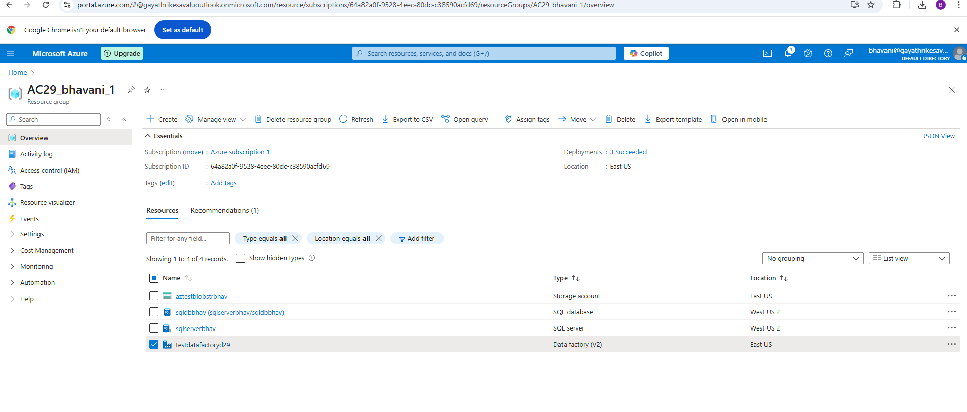

Steps:

* Create a new pipeline and give name to your pipeline as pl_copy_sqldb
* Copy activity as Copy activity and name it as CopyDataFromSQLDB from General tab details
* Then Go to source tab for selecting your source as Azure SQL Database as we are copying data from AzureSqlDB and click on continue.
* Next is Set properties page there give Name of your source for better understanding and linked service details, as we are not created our source yet, we have to click on NEW as mentioned in the screenshot.
* Enter all the deatils in the linked service page as shown in screenshort and click on Test the connection then Create.
* Once linked service is created then slect any Table Name from the list of Tables and click OK
* Next Go to Sink tab and Select the format from the list you want , AZURE DataLake GEN2 and then select decimaltext(CSV) (as i wanted to load delimited text)
* Then give the name and linked service details and also change file format from .txt to .csv
* Next publish and check if the file is loaded or not. File is loaded successfully.

